Design Principles – Encapsulation
# Source: AI Source: Provided by: [Data Path: Persons Table -> ID Column: 1, Name_En Column: Motasem Essam] -> From: [ChatGPT] on [1/23/2026]
Encapsulation is the principle of hiding internal details of a module or component and exposing only what is necessary through a well-defined interface.
👉 Think of it as a black box: you use it, but you don’t need to know how it works inside.

🔑 Key Points
# Source: AI Source: Provided by: [Data Path: Persons Table -> ID Column: 1, Name_En Column: Motasem Essam] -> From: [ChatGPT] on [1/23/2026]
- Protects internal state and implementation
- Prevents other modules from directly modifying internal data
- Helps reduce dependencies and unexpected side effects
- Improves maintainability and flexibility

❌ Bad Example
# Source: AI Source: Provided by: [Data Path: Persons Table -> ID Column: 1, Name_En Column: Motasem Essam] -> From: [ChatGPT] on [1/23/2026]
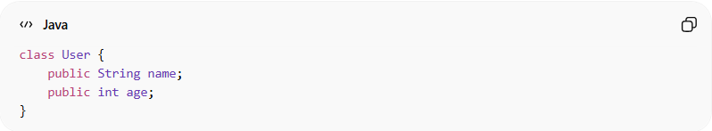
class User {
public String name;
public int age;
}
Problems:
- Internal data is fully exposed
- Any part of the system can modify name or age directly → risky and hard to control

✅ Good Example
# Source: AI Source: Provided by: [Data Path: Persons Table -> ID Column: 1, Name_En Column: Motasem Essam] -> From: [ChatGPT] on [1/23/2026]
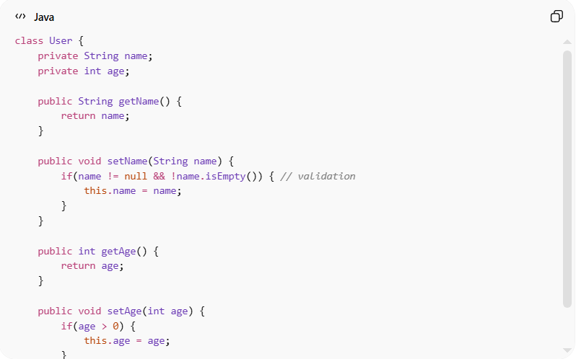
class User {
private String name;
private int age;

public String getName() {
return name;
}

public void setName(String name) {
if(name != null && !name.isEmpty()) { // validation
this.name = name;
}
}

public int getAge() {
return age;
}

public void setAge(int age) {
if(age > 0) {
this.age = age;
}
}
}
Benefits:
- Internal state is protected
- Validation and logic can be applied when data is modified
- Changes to internal implementation don’t affect other modules
- Supports maintainable and safe code

⚡ When to Apply
# Source: AI Source: Provided by: [Data Path: Persons Table -> ID Column: 1, Name_En Column: Motasem Essam] -> From: [ChatGPT] on [1/23/2026]
- Always in object-oriented systems
- Combine with modularity to make modules safe and independent
- Useful for APIs, services, and reusable libraries

